1

OUR LIFE TOGETER

# Bella the super hero and her best friend the Queen beast were on a mission to capture the big fat octopus named Ben. Which we hated so much so we went to Florida to find and stop Ben. Queen and Bella went everywhere together then we found out that when he had his son he turned nice. So now we have to find something else to do or a mission.

# But other super hero’s were in town like super angora ale.so we met most of the super heroes like Bee Bee, Nigeria TT and Kaka those are all the super heroes. We also teamed up with them and called us young so cool heroes .We all went to help people all around the world to save and help people.

**We loved our job so much that we donated at least 100,000 dollars to homeless people and that was so fun to give back to give to the community! Yah it was fun to do so we kept giving to the community.**

**Since we are gong to retire in 106 more years we are going to be greatest heroes as we could we can be. We really don’t want to retire but we have to though so we can stay strong forever so yeah. We are indestrucable we love each other and love the community that is why we fight for justice. We are fun at times that is why we beat up bad people you don’t like, like hurk, rell, chuck, bells and bon we defeat the bad guys.**

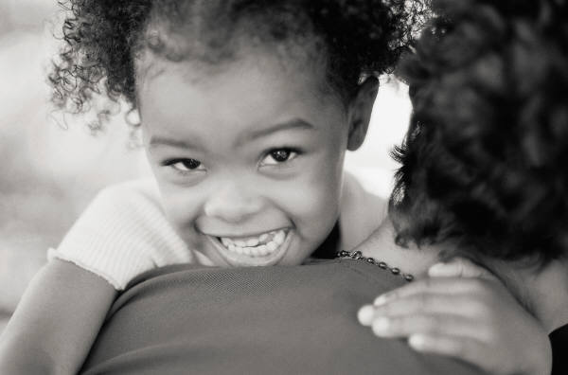

2

We found a new super hero

We were walking in city and we seen a beautiful hero named Beauty Queen. We asked her to be our partner but she said yes and no then she ran off. So we chased her then she stopped we asked her again she said, “Leave me alone” and still ran away. She stopped again and said yes we said come with us. Then we found her a costume she didn’t like so she made her own costume it was SO CUTEEEEEEEEEEEEEE!

They went to the city Beauty Queen, Bella, and Queen Beast went to the city. So they went to the city and left the lab. The reason we left was because we wanted to see what we can do or whom we can save. Then we seen the ugliest villain named Samoa the ugly. Then Beauty Queen said” she so ugly I can’t breath at all”.

So we ran as fast could away from her. She said don’t talk about me next time I see you I will get you three and trap you.

We went back to the lab and ate great food and drunken great smoothies called orange melody. Bella loved them so much she started singing, If it isn’t love by new edition.

3

Bella is trapped

We were walking in the forest